EXP7 MATLAB – Analysis of 5G NR Frame Structure and Subcarrier Spacing
Name: hariharan Reg.no: 1912260124
Objective – 1: Generate / Inspect a Simplified 5G NR Resource Grid
MATLAB PROGRAM
clc; clear; close all;
Nsc = 24; % Simplified number of subcarriers
Nsym = 14; % OFDM symbols per slot
grid = zeros(Nsym,Nsc);
% Simplified DL assignment: symbols 1-10
grid(1:10,:) = 1;
% Simplified UL assignment: symbols 11-14
grid(11:14,:) = 2;
figure
imagesc(grid)
grid on
xlabel('Subcarrier Index')
ylabel('OFDM Symbol Index')
title('Simplified 5G NR Time-Frequency Resource Grid')
colorbar
Result
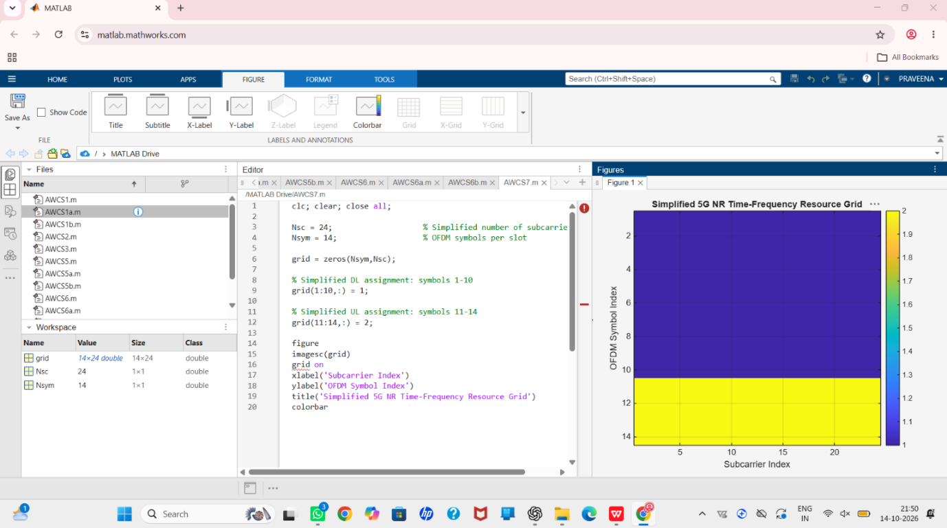
Objective – 2: Compare SCS and Slot Duration
MATLAB PROGRAM:
clc; clear; close all;
scs = [15 30 60 120 240]; % kHz
mu = 0:4;
slot = [1 0.5 0.25 0.125 0.0625]; % ms
figure
plot(scs,slot,'o-','LineWidth',2)
grid on
xlabel('Subcarrier Spacing (kHz)')
ylabel('Slot Duration (ms)')
title('5G NR Slot Duration for Different Subcarrier Spacing')
figure
bar(scs)
grid on
set(gca,'XTickLabel',mu)
xlabel('Numerology Index (\mu)')
ylabel('Subcarrier Spacing (kHz)')
title('5G NR Subcarrier Spacing for Different Numerologies')
Result:
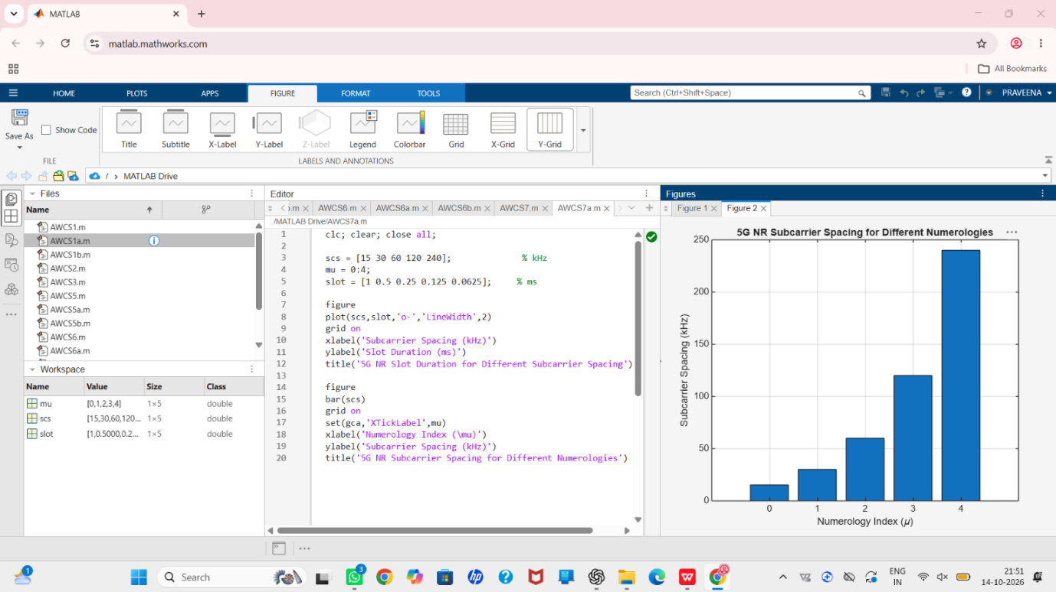

Objective – 3: Identify Basic DL and UL Resource Assignments
MATLAB PROGRAM:
clc; clear; close all;
symbols = 1:14;
DL = [1 1 1 1 1 1 1 1 1 1 0 0 0 0];
UL = [0 0 0 0 0 0 0 0 0 0 1 1 1 1];
figure
plot(symbols,DL,'o-','LineWidth',2); hold on
plot(symbols,UL,'s-','LineWidth',2)
grid on
xlabel('OFDM Symbol Index')
ylabel('Allocation Status')
title('Simplified Downlink and Uplink Assignment')
legend('Downlink','Uplink')
Result:
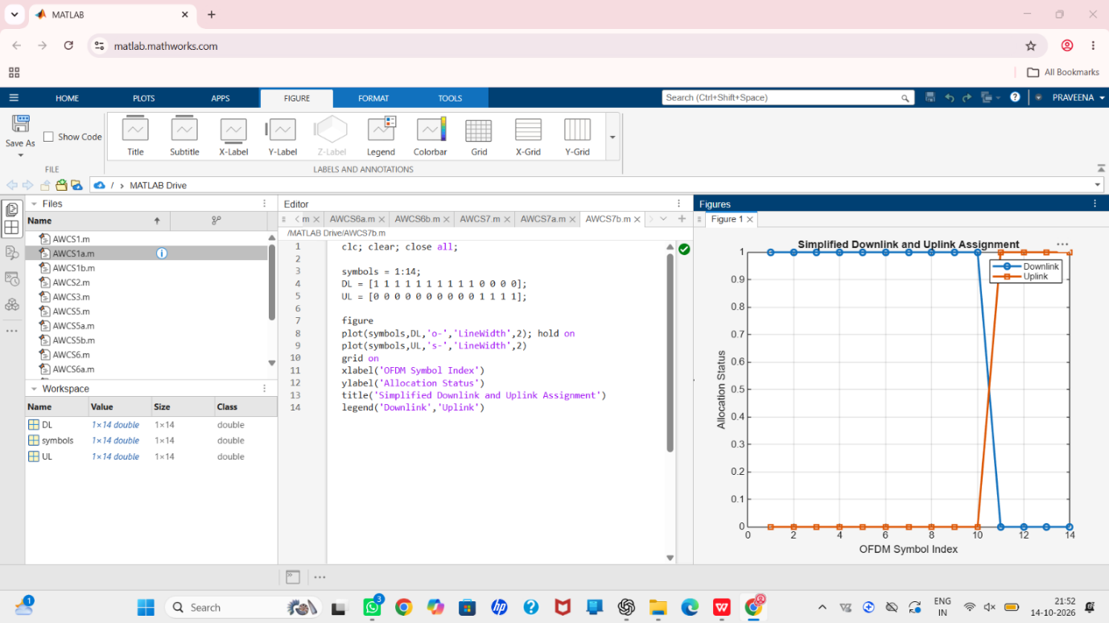

Objective – 4: Relate Resources to gNodeB, RAN and RRC
MATLAB PROGRAM:
clc; clear; close all;
scs = [15 30 60 120 240]; % kHz
mu = 0:4;
slot = [1 0.5 0.25 0.125 0.0625]; % ms
figure
plot(scs,slot,'o-','LineWidth',2)
grid on
xlabel('Subcarrier Spacing (kHz)')
ylabel('Slot Duration (ms)')
title('5G NR Slot Duration for Different Subcarrier Spacing')
figure
bar(scs)
grid on
set(gca,'XTickLabel',mu)
xlabel('Numerology Index (\mu)')
ylabel('Subcarrier Spacing (kHz)')
title('5G NR Subcarrier Spacing for Different Numerologies')
Result:
